CONSENT FORM FOR THE COLLECTION AND DISCLOSURE OF PERSONAL INFORMATION IN THE CONTEXT OF A REAL ESTATE BROKERAGE MANDATE

Identification of the Agency

Royal LePage Du Quartier
6971 Ch. de la Côte de Liesse, Saint-Laurent, QC H4T 1Z3
(514) 419-9888
info@rlpduquartier.com

Represented here by: Karim Dalati
Licence number: D9175
(hereinafter referred to as the "BROKER")

- Carrying on business within the following corporation (if applicable):

Karim Dalati inc.
Name of corporation

(hereinafter referred to as the "AGENCY" and/or "the BROKER") collects, uses, communicates and discloses personal information, in accordance with the provisions of applicable laws and the privacy policy, a copy of which is made available to the individual concerned or which can be consulted online at this address:

HTTPS://WWW.RLPDUQUARTIER.COM/POLITIQUE-DE-CONFIDENTIALITE#
Website address containing the Privacy Policy OR physical address where the Privacy Policy can be viewed

Purposes for Which Personal Information Is Collected and Subject of Consent

The AGENCY and/or BROKER may collect your personal information through this form, verbally, or through other documents submitted or to be submitted as part of the real estate transaction. This personal information is necessary and will be used for the following purposes, among others:
- Verifying your identity.
- Completion of the real estate transaction:
  - If you are bound by a real estate brokerage contract:
    - Marketing of the immovable identified in the brokerage contract for its sale or lease; or
    - Search for properties identified in the brokerage contract for the purchase or lease of a building.
  - If you are not bound by a real estate brokerage contract and the other party is represented by the agency or broker:
As part of its obligation to treat all parties to the transaction fairly, the agency or broker must collect, use and disclose certain personal information of the party(ies) it does not represent that is necessary to complete the real estate transaction relating to the sale, purchase or lease of the property.
  - Maintaining AGENCY and/or BROKER records.
If applicable, your personal information may be communicated outside Québec, communicated, and used by third parties, such as, for example, agents, co-contractors, subcontractors, suppliers of the AGENCY or the BROKER, in accordance with the AGENCY's or the BROKER's privacy policy. As part of the monitoring of the exercise of real estate brokerage activities, your personal information may be communicated, for example, to the Organisme d'autoréglementation du courtage immobilier du Québec or the Fonds d'assurance professionnelle du courtage immobilier du Québec.
In certain cases, provided for by law, your personal information may also be used for purposes other than those described above or disclosed to third parties without your consent.

Consent to Collection and Disclosure of Personal Information

I, , authorize the Broker, the Agency and its agents to:
Name of client(S) or self-represented person(S)

- COLLECT from third parties, i.e. the persons, companies and organizations listed below, all the necessary information concerning me and allowing the Broker, the agency or its agents to complete the mandate given in the context of a real estate transaction.

- COMMUNICATE OR DISCLOSE to third parties, i.e., the persons, companies and organizations listed below, all necessary information concerning me and contained in my file or that may be collected in the context of the real estate transaction for which the Broker, the Agency and its agents have been duly mandated.

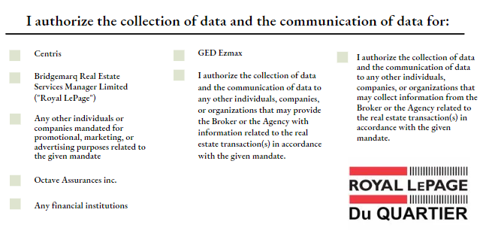

Consent

- I CONFIRM that I have read and understood the information regarding the collection, use, disclosure and disclosure of my personal information. I consent to the collection, use, disclosure and disclosure of my personal information by the AGENCY and/or the BROKER.

- I CONFIRM that this Consent is only given for the purpose of the mandate given to the Agency, the Broker or its agents in the context of the real estate transaction(s) for which they have been duly mandated and only for the period necessary for the execution of the mandate.

- I ACKNOWLEDGE THAT IN THE EVENT OF REFUSAL OR WITHDRAWAL OF MY CONSENT TO THE USE AND COMMUNICATION OF MY PERSONAL INFORMATION, THE AGENCY and/or the BROKER may not be able to provide me with its services in connection with the completion of the real estate transaction.

- I CONFIRM that, following the end of the execution of its mandate, I authorize the AGENCY, BROKER, or its agents, to contact me for marketing or promotional purposes.

Right of access, withdrawal and rectification

- I CONFIRM that I have been informed that, subject to certain conditions, the law recognizes my right to access my personal information.

- I also CONFIRM that I have been informed that I may withdraw my consent to the use, communication, and disclosure of my personal information at any time and that I may request the rectification of personal information held by the AGENCY and/or the BROKER if it is inaccurate, incomplete or ambiguous.

- I CONFIRM that I have been advised that the withdrawal of my consent may result in the AGENCY and/or the BROKER no longer being able to provide its services in connection with the completion of the real estate transaction.

- I CONFIRM that I have been notified that the withdrawal of my consent for the collection, use, communication and disclosure to Centris Corporation Inc. and Royal Lepage Real Estate Services will prevent the AGENCY and/or the BROKER from providing me with services in connection with the completion of the real estate transaction and will thus terminate the Contract between the AGENCY and/or the BROKER and myself.

By signing this Consent Form, I confirm and acknowledge that I have read and understood the scope of the consent provided.

IN WITNESS WHEREOF, I HAVE SIGNED:

____________________________
signature

